**Preparation and Characterization of Chitosan and Ethylene Glycol Based Chitosan Films**

Arhama Baria, Sadiq Hussaina*, Maham Hussaina,Najaf Alib, Akhtar Ali Malika

a Chemical Engineering Department, NFC Institute of Engineering and Technology,

b NFC Institute of engineering and Fertilizer Research Fasilabad

Multan, Punjab, Pakistan

bNFC Institute of Engineering and Technology,

Multan, Punjab, Pakistan

Corresponding Author*: sadiqhussain@nfciet.edu.pk

**Abstract**

Environmental concerns associated with packaging materials opened a new challenging research domain for the researchers to investigate the new materials, which could minimize the raised issues and provide a better shelf life to the products. In this regard, natural polymers such as Chitosan has been blended with numerous materials for the development of packaging films. Knowledge of physiochemical properties of new films is essential before using them for packaging. In the present work, Chitosan films are produced using different Ethylene Glycol based solvents. Further, these blended films are characterized in terms of FTIR, TGA, DSC, FESEM, and EDX analysis. The addition of different Ethylene Glycol with the Chitosan shifted the peaks, changed their thermal and endo/exothermic profiles. The images revealed the micro-sized films with better surfaces, which could be good as packaging material.

**Keywords:** Chitosan; Ethylene Glycol; Packaging Films

# **Introduction**

Microbial growth and metabolism in the products may results in physical damage, chemical changes (oxidation, colour change) or appearance of off-flavours and off-odours [1], [2]. This microbial spoilage may develop the visible colonies resulting in a short life, especially food products, which have high nutrition, neutral pH and high moisture contents [3]. Food spoilage becomes more serious when producing food pathogens, which affects human health. Several anti-microbial compounds have been used for preservation purpose and yet many chemicals are in the process of exploration to be used as product preservatives [4]–[8]. The packaging is considered one of the good ways to maintain the quality of food product and increasing its shelf life [9]. Though much improvements are seen using the new materials and blends, some concerns are also highlighted stating the food and environmental problems [10]. The replacement of harmful plastics engaged the researchers to investigate the new film-forming materials [11]. Both natural and synthetic polymers are widely studied for film-forming applications [12]. The biodegradable polymers are considered a good alternative for overcoming the raised environmental and health concerns. Among natural biodegradable polymers, Chitosan is the well-known biopolymer comprises unique properties, which make it effective to be used for the various applications [13]–[16]. Due to biodegradable and biocompatible characteristics, it is considered good for packaging film forming [17]–[20]. Though Chitosan is widely investigated using other polymers, solvents, and materials for the film making [21]–[25], there is a need to explore in this field. New blended films may provide further benefits to the packaging industry. Physiochemical properties of the films play a significant role, and their understanding is essential. This has motivated us to prepare new films using the blends of Chitosan with different types of Ethylene Glycol and study their properties.

# **Methodology**

## **2.1 Materials**

All the chemicals with specifications are provided in Table 1. These chemicals were used without any further purification.

Table 1. Specification of Materials

|  |  |  |
| --- | --- | --- |
| **Chemicals** | **Brand** | **Specification** |
| Chitosan | Sigma Aldrich | Low molecular weight |
| Acetic Acid | Sigma Aldrich | (Glacial) |
| Ethylene Glycol | Sigma Aldrich | ≥ 99.00 % |
| Poly-ethylene Glycol | Sigma Aldrich | ≥ 99.00 % |
| Tri Poly-ethylene Glycol | Sigma Aldrich | ≥ 99.00 % |
| Tetra Poly-ethylene Glycol | Sigma Aldrich | ≥ 99.00 % |

## **2.2 Selection of Chitosan Concentration**

Chitosan concentration has significant preservative effects, and its optimized amount may protect the materials in a better way. Therefore, in the present work, Chitosan solutions in the range of 1 to 6 % w/v were prepared, and equal-sized pieces of potato suspended in them and placed at room temperature. The deterioration of potato pieces was noted by visual analysis for one month with an interval of one week. The most suitable concentration was further chosen for formation of Chitosan films.

## **2.3 Preparation of Chitosan and Chitosan-Ethylene Glycol based Films**

The preparation of the Chitosan film was carried out by adopting the literature [18]–[20] with some modification. Initially, the Chitosan solution of 5 % (w/v) was prepared by dissolving it into the 1 % (w/v) acetic acid. This solution was stirred for 24 hours at room temperature and 600 rpm by using a magnetic stirrer. The impurities were removed by filtration of Chitosan solution, and it was placed in a vacuum oven for 30 minutes to remove unwanted bubbles. This solution was then placed in the oven and dried for 48 hours at 30 ˚C. The prepared Chitosan film was then washed with distilled water and dried again for the same period and stored for characterization.

The Ethylene Glycol solvents modified Chitosan films were also produced by a similar method, as mentioned above. In this case, initially, the Chitosan solution of 5 % (w/v) was produced, and then 1 % (w/v) of each Ethylene Glycol, Poly-ethylene Glycol, Tri-ethylene Glycol, and Tetra-ethylene Glycol was added to the chitosan solution and stirred for 4 hours to homogenize the mixture. Afterwards, similar methods of bubble removing, washing and drying were carried. Finally, all the modified Chitosan films were stored for the characterization purpose.

## **2.4 Characterization of Chitosan and Chitosan-Ethylene Glycol Antimicrobial Films**

The prepared Chitosan and various forms of Ethylene Glycol blended/modified Chitosan films were characterized in terms of structural changes, thermal stability, endo/exo-thermograms, and morphology. The structural changes caused in Chitosan and modified Chitosan films were conducted by using FTIR analysis. This study was conducted between 4000-400 cm-1 and functional peaks of pure LMW Chitosan, Chitosan films, and modified Chitosan films were recorded. The thermal stability of prepared Chitosan and modified Chitosan films were determined by thermogravimetric (TGA) analysis. For this purpose, testing was conducted in the temperature range of 40 ˚C to 400 ˚C at a heating rate of 10 ˚C/min by using TGA. Nitrogen was used as inert gas for purging during the analysis of all sample films. The DSC analysis of Chitosan and modified Chitosan films were conducted in the range of the 25-400 ˚C, and around 5 mg of each sample was placed in the pan for estimating the heat flow behaviour in a specific time and temperature range. Since the surface morphology of any material is best to understand by investing its structure at nano/micro levels, the prepared Chitosan and modified Chitosan films were studied by the FESEM analysis. For this purpose, the surface as well as cross-section side of the films for investigating.

# **Results and Discussion**

## **Selection of Optimum concentration for Chitosan Film formation**

Some preliminary experiments were conducted selecting a range of 1-6 % w/v Chitosan solutions and distilled water with potato pieces. The visual analysis was conducted for one month with an interval of one week. The potato sample in the distilled water exhibited swelling, and its surface tore just after one week. This might be due to the fast water diffusion, which expanded its structure and caused surface deterioration. This expansion and surface changes increased in the second and third week, and while reaching the fourth week, high swelling and deterioration of the sample were observed. Whereas, the samples placed in the Chitosan solutions did not exhibit any unusual changes during one to three weeks revealing good preservatives environment for the sample. After the fourth week, the samples placed in 1-4 % w/v Chitosan solutions exhibited slight changes in their structure. In case of the sample placed in 5 % w/v Chitosan solution, no structural changes were observed, while the higher concentration (6% w/v) caused shrink/contraction of the sample surface as that of normal size. This revealed that the 5 % w/v Chitosan solution could protect the sample from expansion, shrink/contraction or deterioration (no significant changes), and could be useful for packaging film formation. Therefore, this concentration was selected for the Chitosan and Chitosan-Ethylene Glycol based film formation.

## **Preparation of Chitosan and Ethylene Glycol modified Chitosan Films**

Chitosan and Chitosan modified by the Ethylene Glycol, Poly-ethylene Glycol, Tri-ethylene Glycol, and Tetra-ethylene Glycol-based films were produced by the casting method as mentioned before. These films can be seen in Figure 1.

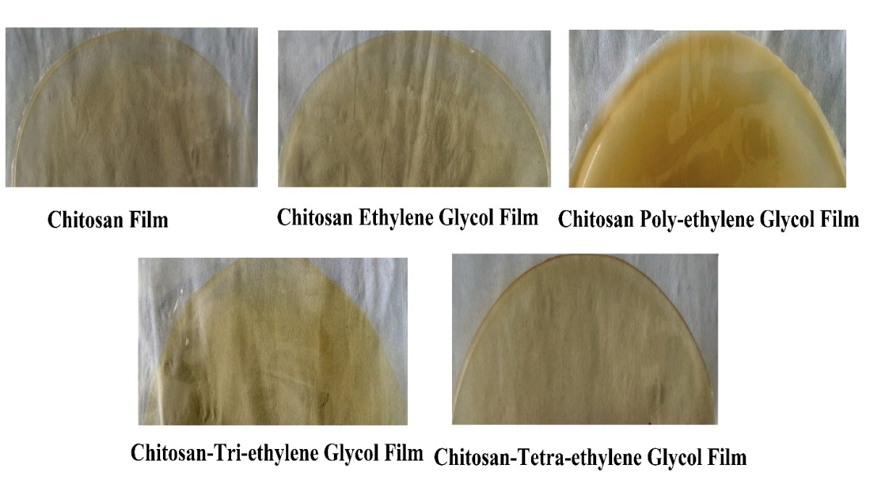

Figure 1. Chitosan and Ethylene Glycol modified Chitosan Films

The visual analysis showed that the films produced by different solvents have different opaqueness. Among different films, Chitosan and Chitosan-Tetra-ethylene Glycol films showed better transparency. In comparison, the later one possessed a smooth surface, more transparency and strength. The Chitosan films based on Ethylene Glycol and Tri-ethylene Glycol showed less transparency, but better surfaces as compared with the Chitosan film. The Chitosan-Poly-ethylene Glycol was darker in colour, and thick surface as compared with other types of Ethylene Glycol blended films.

## **3.3 Characterization of Chitosan and Ethylene Glycol modified Chitosan Films**

### 3.3.1 Fourier transform Infrared (FTIR)

All the synthesized Chitosan films were characterized by the FTIR analysis. This analysis was conducted to determine the structural changes caused by the modifiers. The IR spectra of Pure Chitosan (LMW), Chitosan and different types of Ethylene Glycol blended Chitosan films are shown in Figure 2.

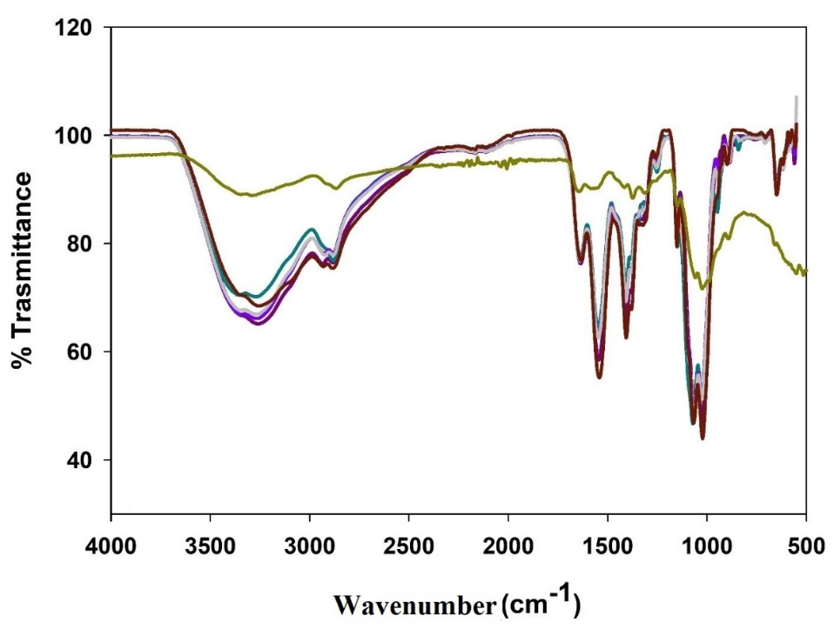

Figure 2. FTIR analysis of films: ▬, pure Chitosan; ▬, Chitosan 5 % w/v; ▬, Chitosan-Ethylene Glycol; ▬, Chitosan-Poly-ethylene Glycol; ▬, Chitosan-Tri-ethylene Glycol and ▬, Chitosan-Tetra-ethylene Glycol

For a better understanding, the IR spectra are presented on separate scales (Figures 3 a, b, c and d). The pure Chitosan has a broader peak with two doublets at 3344 cm-1 and 3273 cm-1, which in case of Chitosan film, Chitosan-Ethylene Glycol, Chitosan-Poly-ethylene Glycol, Chitosan-Tri-ethylene Glycol, and Tetra-ethylene Glycol films were observed at 3357 and 3264 cm-1, 3354 and 3271 cm-1, 3368 and 3281 cm-1, 3365 and 3275 cm-1, 3368 and 3280 cm-1 respectively. These peaks are results of O-H stretching vibration and N-H stretching due to primary amine and amide II [26], [27]. Similarly, another small doublet for pure Chitosan was observed in the region of 2911 cm-1 and 2855 cm-1, which in the case of the above-mentioned films (same sequence) was observed at 2943 and 2893 cm-1, 2933 and 2890 cm-1, 2935 and 2892 cm-1, 2934 and 2890 cm-1 respectively. These peaks are the results of C-H asymmetric stretching. In literature, a broader peak for Chitosan-based film was found between 3550-3200 cm-1 due to O-H and amino group stretching vibration, and a doublet at 2920 cm-1 and 2872 cm-1 represents CH2 stretching [28]. Some overlapped peaks of Ethylene Glycol group due to O-H and C-H also exist in the regions 3400-3200 cm-1 and 2930-2877 cm-1 respectively [29]. Pure Chitosan also exhibited some peaks in the regions 1700-1300 cm-1. Similarly, pure Chitosan exhibited two small peaks at 1640 cm-1 and 1568 cm-1 due to amide I, and II. Two peaks at 1410 cm-1and 1370 cm-1 due to stretching and deformation vibration of C-H bonds. In the case of Chitosan and modified Chitosan films, these peaks shifted between 1640-1550 cm-1 and a doublet peak between 1410-1385 cm-1 was observed with different transmittance. In comparison, the Chitosan and modified Chitosan films possessed almost similar peaks with varying transmittance in this region. In literature, the absorption bands for Chitosan films indicating the amide I was found at 1634, and amide II between 1554-1535 cm-1 respectively [28], [30]. Whereas, the C-H bending was found at 1410 cm-1 [31].

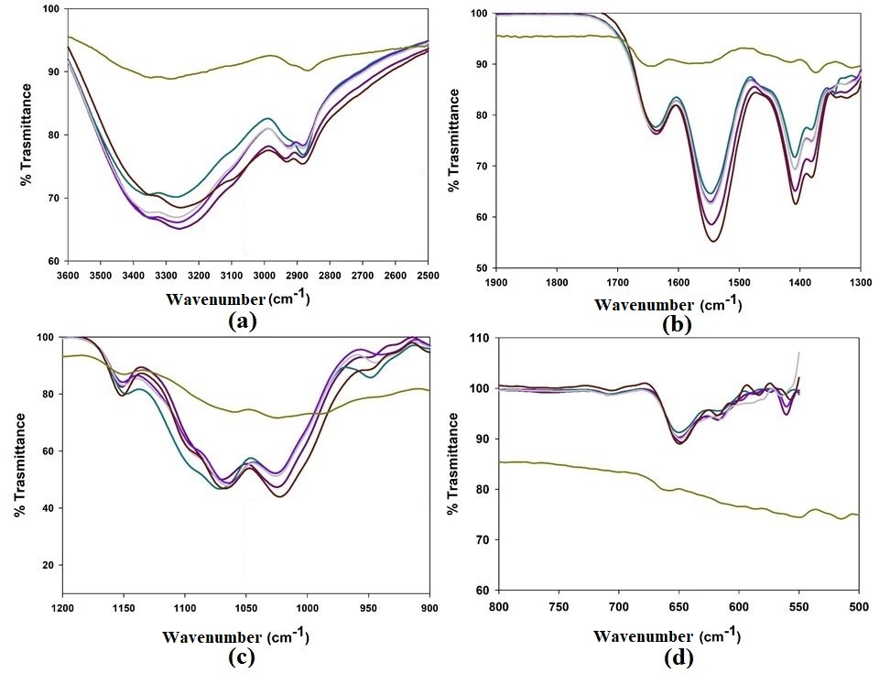

Figure 3. FTIR analysis of films: (a), 3600-2800 cm-1; (b), 1700-1300 cm-1; (c), 1200-900 cm-1 and (d), 700-500 cm-1; ▬, pure Chitosan; ▬, Chitosan 5 % w/v; ▬, Chitosan-Ethylene Glycol; ▬, Chitosan-Poly-ethylene Glycol; ▬, Chitosan-Tri-ethylene Glycol and ▬, Chitosan-Tetra-ethylene Glycol

In the region of 1200-900 cm-1, the pure Chitosan possessed two small peaks at 1058 cm-1 and 1024 cm-1 due to skeletal vibration of C-O stretching. In the case of the Chitosan and modified Chitosan films, these peaks shifted between 1074-1024 cm-1. Literature indicated the C-O stretching of Chitosan film between 1060-1022 cm-1 [26]. Similarly, two overlapped peaks are expected between 1086-1040 cm-1 due to the presence of Ethylene Glycol group [29]. All the prepared films showed a peak at 650 cm-1 due to C-H bending (out plane vibrations) which is sharp and broader as compared with pure Chitosan at a similar wavenumber.

### 3.3.2 Thermogravimetric Analysis (TGA)

Thermal stability is one of the significant properties of the materials, which may affect its entire performance for any specific application. Numerous studies have highlighted the significance of this property, especially related to Chitosan [32]. In the present research, thermogravimetric analysis (TGA) of the pure Chitosan (5 % w/v) and different Ethylene Glycol modified chitosan films was conducted in the range of 50 ˚C to 400 ˚C. For this purpose, the temperature was divided into four sections with an interval of 100 ˚C and the mass loss of these films was observed. The Chitosan and the modified Chitosan films exhibited different thermal behaviours in different temperature ranges (Figure 4).

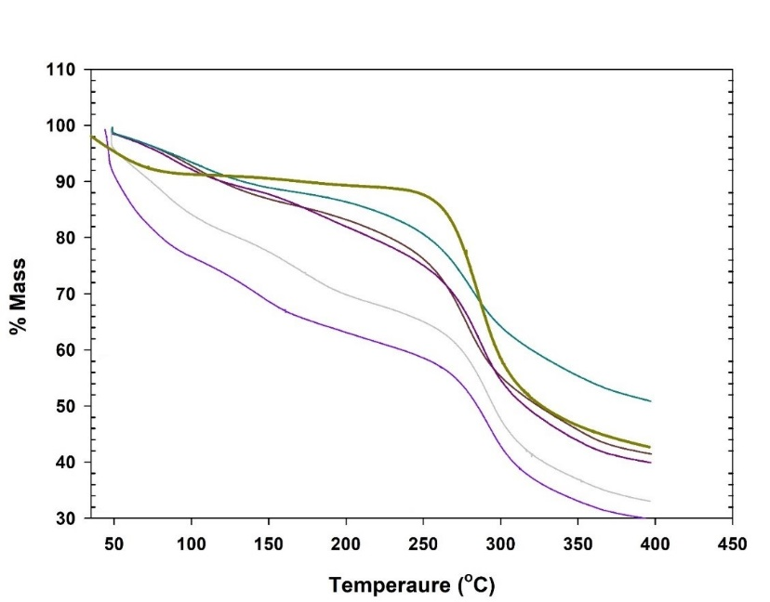

Figure 4. TGA of Films: ▬, pure Chitosan; ▬, Chitosan 5 % w/v; ▬, Chitosan-Ethylene Glycol; ▬, Chitosan-Poly-ethylene Glycol; ▬, Chitosan-Tri-ethylene Glycol and ▬, Chitosan-Tetra-ethylene Glycol

For the first interval (50-100 ˚C), the Chitosan (5 % w/v) exhibited a sudden but slow mass loss of around 9.0 %. In a similar interval, the Chitosan film (5 % w/v) and Chitosan-Ethylene Glycol film started to lose slowly and showed almost similar thermal behaviour around 7.25 % and 7.85 % mass loss respectively while reaching 100 ˚C. The Chitosan-PolyEthylene Glycol film showed a mass loss of around 6.55 % in a similar temperature range which was slightly lower than the above-mentioned films. On the other hand, Chitosan-Tetra-ethylene Glycol and Chitosan-Tri-ethylene Glycol showed the highest mass loss (around 15.90 % and 23.35 respectively) in this temperature range (50-100 ˚C). Overall, the sequence of mass loss for 50-100 ˚C was found as Chitosan-Tri-ethylene Glycol film> Chitosan-Tetra-ethylene Glycol> Pure Chitosan (LMW)> Chitosan-Ethylene Glycol> Chitosan-Poly-ethylene Glycol film. Between the temperature range of 100 to 200 ˚C, all the chitosan films followed the same order of mass loss except the pure Chitosan (LMW). In this case, the order was found as Chitosan-Tri-ethylene Glycol> Chitosan-Tetra-ethylene Glycol> Chitosan-Ethylene Glycol> Chitosan-Poly-ethylene Glycol> Chitosan> Chitosan-Poly-ethylene Glycol> Pure Chitosan (LMW) with a total mass loss of around 36.96, 30.20, 18.06, 16.84, 13.63, and 10.69 % respectively. A study conducted on Chitosan and its biocomposites revealed a loss of 6-8 % between 100-200 ˚C and around 60 % between 210-410 ˚C [33]. Another thermal stability study based on Chitosan films with/without citronella essential oil and cedarwood oil also exhibited around 5.90-9.18 % loss between 100-122 ˚C [34]. The third zone (200-300 ˚C) is considered the critical temperature range since all the Chitosan films, and pure Chitosan (LMW) showed a significant mass loss. The results indicated that the degradation rate of the films and pure Chitosan (LMW) increases in this temperature range and the order of mass loss was found as Chitosan-Tri-ethylene Glycol> Chitosan-Tetra-ethylene Glycol> Chitosan-Ethylene Glycol> Chitosan> pure Chitosan (LMW)> Chitosan-Poly-ethylene Glycol with a total mass loss of around 57.35, 52.60, 45.85, 44.45, 41.65, and 35.80 % respectively. The fourth zone (300-400 ˚C) showed a continuous mass loss of Chitosan films and pure Chitosan (LMW), however, the Chitosan and Chitosan-PolyEthylene Glycol films comparatively exhibited slow degradation. The order of the mass loss was found as Chitosan-Tri-ethylene Glycol> Chitosan-Tetra-ethylene Glycol> Chitosan-Ethylene Glycol> Chitosan> pure Chitosan (LMW)> Chitosan-Poly-ethylene Glycol with a total mass loss of around 70.34, 67.26, 60.31, 58.47, 57.10 and 49.00 respectively. Overall, it was found that Chitosan-Poly-ethylene Glycol film had better thermal stability and can withstand high temperatures as compared with the other prepared films. Similarly, Chitosan and Chitosan-Ethylene Glycol also exhibited good thermal stability. Among all the prepared films, Chitosan-Tetra-ethylene Glycol and Chitosan-Tri-ethylene Glycol showed the least thermal stability and degraded faster with the increase in temperature.

### 3.3.3 Differential Scanning Calorimeter (DSC)

The DSC analyses for the pure Chitosan and various Chitosan films were conducted in the temperature range of 25 to 400 ˚C. Different trends of endothermic and exothermic peaks were found for the prepared Chitosan films (Figure 5). In the case of unmodified Chitosan film (5 % w/v), a sharp and wide endothermic peak was observed at 111.0 ˚C, while a small exothermic peak appeared at 268 ˚C. In a DSC study of Chitosan and its blended films, the pure Chitosan film exhibited a broader endothermic peak around 79 ˚C [31]. In another study, the Chitosan control film showed two endothermic peaks (at 72.24 and 154.64 ˚C), and one exothermic peak (at 269.65 ˚C) [35]. Similarly, a Chitosan film (2 % wt.) showed an endothermic peak at 59 ˚C and exothermic around 273 ˚C [36]. In the current study, the addition of Ethylene Glycol to Chitosan shifted the endothermic peak to an earlier temperature of 101.0 ˚C. The exothermic peak for this film was found at the 268 ˚C as observed for the Chitosan film. The endothermic peak is a result of water evaporation from the films, and the exothermic peak represents the film degradation [31], [37]. The addition of Ethylene Glycol slightly changed the crystal structure of Chitosan, and less energy is required for the removal of residual water from the film surface, but the degradation behaviour was not affected. The Chitosan-Poly-ethylene Glycol film showed two small endothermic peaks at temperatures (103.0 ˚C and 190 ˚C). In comparison to the second endothermic peak, the first seems wider and less sharp. The wider peak might be due to loosely bonded water molecules which took less energy for removal, while the sharper peak due to strongly bounded water molecules that need more energy to remove them from the surface of Chitosan-Poly-ethylene Glycol film. The DSC analysis of this film indicated that it did not possess any significant exothermic peak. The Chitosan-Tri-ethylene Glycol film showed a wider endothermic peak between 105-115 ˚C and a significant exothermic peak at 301 ˚C. The Chitosan-Tetra-ethylene Glycol film showed one wide and sharp endothermic peak at 96 ˚C and some insignificant peaks at 212 ˚C and 235 ˚C.

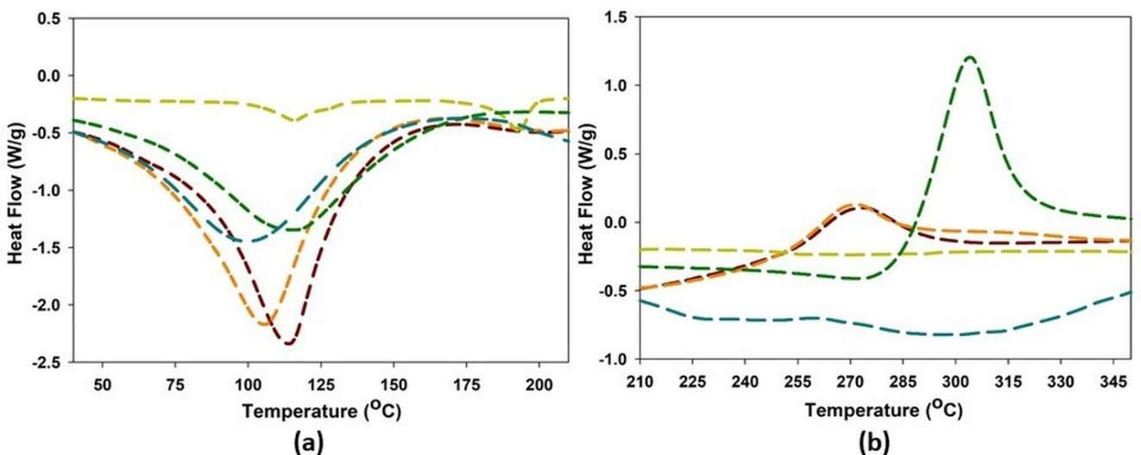

Figure 5. DSC of films: ▬, Chitosan 5 % w/v; ▬, Chitosan-Ethylene Glycol; ▬, Chitosan-Poly-ethylene Glycol; ▬, Chitosan-Tri-ethylene Glycol and ▬, Chitosan-Tetra-ethylene

### Field Emission Scanning Electron Microscopy

The FESEM analysis was conducted for all the prepared films (Figure 6). In this regard, the top flat surface and crossectional sides of the films were characterized at the microscale. In the case of Chitosan film, most of the flat surface seemed plain without pores; however, some nanoparticles clusters were found on it. The crossectional side of this film revealed that it has a thickness of 127 μm at 89.9o. The addition of Ethylene Glycol to Chitosan solution produced Chitosan-Ethylene Glycol film with a smooth flat surface without the presence of any nano/microparticles on the surface. The crossectional view indicated that the Ethylene Glycol increased the thickness of the Chitosan film, which is 141 μm at 89.9o. The FESEM analysis of the Chitosan-Poly-ethylene Glycol films showed that its surface was not flat and comprised of pores (nano-sized). This is also obvious in the crossectional side of the film, and its thickness (123 μm at 89.9o) was slightly less than the Chitosan film. This structure showed an unsmooth surface but might be suitable for further modification with some other solvents for the food packaging. The porous materials can adsorb the materials, which could be a positive point. The FESEM analysis of Chitosan-Tri-ethylene Glycol film showed that Tri-ethylene Glycol further reduced the thickness of the film, but the top surfaced was smooth without pores and rupture. The crossectional analysis showed that the thickness of the film was further reduced to 111 μm at 89.9o. The FESEM analysis of the Chitosan-Tetra-ethylene Glycol film indicated that it possesses a smooth top surface, while the crossectional side had some porous structure. The addition of Tetra-ethylene Glycol to Chitosan increased the film thickness (146 μm at 89.9o) as compared with Chitosan film.

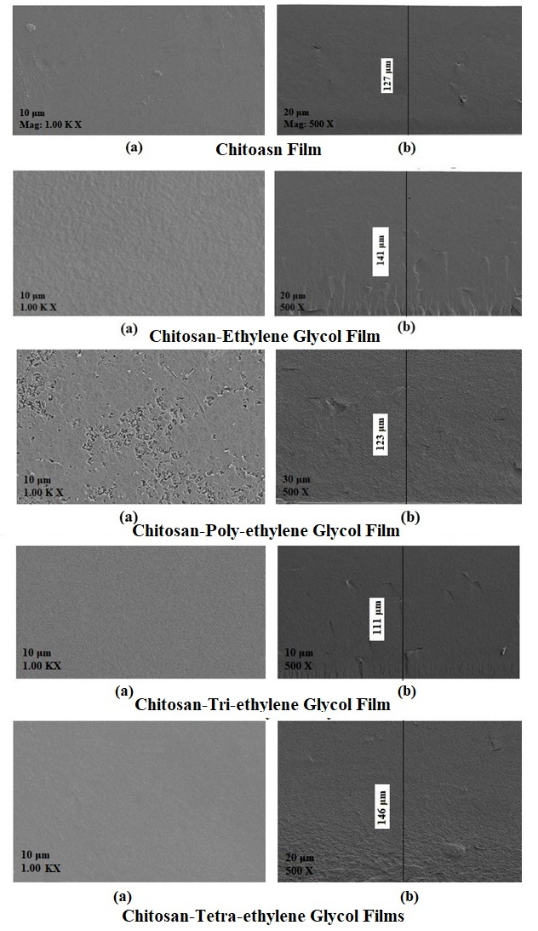

Figure 6. FESEM of (a), surface and (b), cross-section of films

* + 1. **Energy Dispersive X-ray (EDX)**

The EDX analysis was conducted to investigate the elemental changes caused by different Ethylene Glycol based solvents. The Chitosan film has a composition of Carbon, Nitrogen, and Oxygen of 46.49, 2.65, and 50.86 % wt. respectively. The addition of the Ethylene Glycol changed this composition of Carbon, Nitrogen, and Oxygen as 48.32, 0.86, 50.82 % wt. respectively. In this case, the Carbon contents were increased due to the modification of Chitosan with Ethylene Glycol, while the Nitrogen reduced, and Oxygen remained almost similar to that of Chitosan film. When the Chitosan was modified with Poly-ethylene Glycol for film-forming, the composition of Carbon, Nitrogen, and Oxygen became 49.13, 1.00, 49.88 % wt. respectively. The addition of this solvent further increased the Carbon contents and reduced the Oxygen contents. In this case, the Nitrogen contents were slightly higher than that of Ethylene Glycol based Chitosan film. When the Tri-ethylene Glycol was added with Chitosan it eliminated the Nitrogen contents, while Carbon and Oxygen contents increased to 49.92 and 50.08 % wt. respectively. However, the Oxygen contents remained lower than that of Chitosan and Chitosan-Ethylene Glycol films. In the case of Tetra-ethylene Glycol modified Chitosan film, the Carbon contents (50.19 % wt.) further increased, while oxygen (49.81 % wt.) decreased and Nitrogen eliminated. This trend of increase in Carbon, decrease in Oxygen, and Nitrogen contents elimination was more obvious when the modifier was changed from Ethylene Glycol to Tetra-ethylene Glycol.

# **4 Conclusion**

Chitosan and its blend with Ethylene Glycol based solvents helped in improving the film characteristics. The concentration of Chitosan is a significant factor, which can affect the properties of food to be preserved. In present work, the effects of chitosan concentrations were studied by preserving the potato pieces in which the 5 % w/v selected for film formation. The Chitosan and different Ethylene Glycol based Chitosan films were prepared and characterized in terms of FTIR, TGA, DSC, FESEM and EDX analysis. These films possess good thermal stability and their endo/exothermic profiles changed depending on the type of Ethylene Glycol used. The morphology of the prepared films revealed their micro thickness and smooth surfaces (except Chitosan-Poly-ethylene Glycol film), which could be good for packaging purposes. Further, some of these films have a porous structure, which has nano-sized pores and may be further modified or tailored for the development of packaging material. Overall, Chitosan and its Ethylene Glycol Blended films possessed better characteristics to be used as packaging material.

# **Acknowledgement**

The authors would like to thank the NFC Institute of Engineering and Technology Multan for providing financial and technical support.

# **Declarations**

## **Ethical Approval**

Not applicable

## **Consent to Participate**

Not applicable

## **Consent to Publish**

Not applicable

## **Authors Contributions**

A. B (First author) performed the experiments and written the manuscript. The S. H and T. I. Q (co-authors) supervised and provided the directions for experiments and characterization. A. A. M and K. S. A. (co-authors) helped as advisory members in experiments and manuscript writing.

## **Funding**

Funding sources are mentioned in the acknowledgement section. No additional funding source supported this study.

## **Competing Interests**

The authors declare that they have no competing interests in this section

## **Availability of Data and Materials**

Not applicable

# **References**

[1] T. N. Sherratt, D. M. Wilkinson, and R. S. Bain, “Why fruits rot, seeds mold and meat spoils: A reappraisal,” *Ecol. Modell.*, vol. 192, no. 3–4, pp. 618–626, 2006.

[2] S. Rawat, “Food Spoilage: Microorganisms and their prevention,” *Pelagia Res. Libr. Asian J. Plant Sci. Res.*, vol. 5, no. 4, pp. 47–56, 2015.

[3] P. A. Bron and M. Kleerebezem, “Engineering lactic acid bacteria for increased industrial functionality,” *Bioeng. Bugs*, vol. 2, no. 2, 2011.

[4] S. A. Cichello, “Oxygen absorbers in food preservation: a review,” *J. Food Sci. Technol.*, vol. 52, no. 4, pp. 1889–1895, 2015.

[5] K. B. Biji, C. N. Ravishankar, C. O. Mohan, and T. K. Srinivasa Gopal, “Smart packaging systems for food applications: a review,” *J. Food Sci. Technol.*, vol. 52, no. 10, pp. 6125–6135, 2015.

[6] S. Sugumar, V. Ghosh, A. Mukherjee, and N. Chandrasekaran, *Essential oil-based nanoemulsion formation by low- and high-energy methods and their application in food preservation against food spoilage microorganisms*. Elsevier Inc., 2015.

[7] I. Rasooli, “Food preservation – A biopreservative approach Food Preservation – A Biopreservative Approach,” no. January 2007, 2017.

[8] J. Weiss, S. Gaysinsky, M. Davidson, and J. McClements, *Nanostructured Encapsulation Systems*. 2009.

[9] B. Malhotra, A. Keshwani, and H. Kharkwal, “Antimicrobial food packaging: Potential and pitfalls,” *Front. Microbiol.*, vol. 6, no. JUN, pp. 1–9, 2015.

[10] S. Ribes, A. Fuentes, P. Talens, and J. M. Barat, “Prevention of fungal spoilage in food products using natural compounds: A review,” *Crit. Rev. Food Sci. Nutr.*, vol. 58, no. 12, pp. 2002–2016, 2018.

[11] P. K. Dutta, S. Tripathi, G. K. Mehrotra, and J. Dutta, “Perspectives for chitosan based antimicrobial films in food applications,” *Food Chem.*, vol. 114, no. 4, pp. 1173–1182, 2009.

[12] I. S. M. A. Tawakkal, M. J. Cran, J. Miltz, and S. W. Bigger, “A review of poly(lactic acid)-based materials for antimicrobial packaging,” *J. Food Sci.*, vol. 79, no. 8, 2014.

[13] G. Crini, “Historical review on chitin and chitosan biopolymers,” *Environ. Chem. Lett.*, no. Ilkewitsch 1908, pp. 1–21, 2019.

[14] H. Wang, J. Qian, and F. Ding, “Emerging Chitosan-Based Films for Food Packaging Applications,” *J. Agric. Food Chem.*, vol. 66, no. 2, pp. 395–413, 2018.

[15] M. C. G. Pellá, M. K. Lima-Tenório, E. T. Tenório-Neto, M. R. Guilherme, E. C. Muniz, and A. F. Rubira, “Chitosan-based hydrogels: From preparation to biomedical applications,” *Carbohydr. Polym.*, vol. 196, no. January, pp. 233–245, 2018.

[16] P. Cazón, G. Velazquez, J. A. Ramírez, and M. Vázquez, “Polysaccharide-based films and coatings for food packaging: A review,” *Food Hydrocoll.*, vol. 68, pp. 136–148, 2017.

[17] R. Domínguez *et al.*, “Active packaging films with natural antioxidants to be used in meat industry: A review,” *Food Res. Int.*, vol. 113, pp. 93–101, 2018.

[18] M. Mujtaba *et al.*, “Current advancements in chitosan-based film production for food technology; A review,” *Int. J. Biol. Macromol.*, vol. 121, pp. 889–904, 2019.

[19] H. El Knidri, R. Belaabed, A. Addaou, A. Laajeb, and A. Lahsini, “Extraction, chemical modification and characterization of chitin and chitosan,” *Int. J. Biol. Macromol.*, vol. 120, pp. 1181–1189, 2018.

[20] F. Liu, W. Chang, M. Chen, F. Xu, J. Ma, and F. Zhong, “Tailoring physicochemical properties of chitosan films and their protective effects on meat by varying drying temperature,” *Carbohydr. Polym.*, vol. 212, pp. 150–159, 2019.

[21] T. Huang, Y. Qian, J. Wei, and C. Zhou, “Polymeric Antimicrobial food packaging and its applications,” *Polymers (Basel).*, vol. 11, no. 3, 2019.

[22] F. Bi, X. Zhang, R. Bai, Y. Liu, J. Liu, and J. Liu, “Preparation and characterization of antioxidant and antimicrobial packaging films based on chitosan and proanthocyanidins,” *Int. J. Biol. Macromol.*, vol. 134, pp. 11–19, 2019.

[23] S. Roy and J. Rhim, “Food Hydrocolloids Preparation of carbohydrate-based functional composite films incorporated with curcumin,” *Food Hydrocoll.*, vol. 98, no. August 2019, p. 105302, 2020.

[24] S. Tripathi, G. K. Mehrotra, and P. K. Dutta, “Preparation and physicochemical evaluation of chitosan / poly ( vinyl alcohol )/ pectin ternary film for food-packaging applications,” *Carbohydr. Polym.*, vol. 79, no. 3, pp. 711–716, 2010.

[25] P. C. Srinivasa, M. N. Ramesh, and R. N. Tharanathan, “Effect of plasticizers and fatty acids on mechanical and permeability characteristics of chitosan films,” *Food Hydrocoll.*, vol. 21, pp. 1113–1122, 2007.

[26] D. Kumar, P. Kumar, and J. Pandey, “Binary grafted chitosan film: Synthesis, characterization, antibacterial activity and prospects for food packaging,” *Int. J. Biol. Macromol.*, vol. 115, no. October, pp. 341–348, 2018.

[27] C. Ungureanu, D. Ioniţǎ, E. Berteanu, L. Tcacenco, A. Zuav, and I. Demetrescu, “Improving natural biopolymeric membranes based on chitosan and collagen for biomedical applications introducing silver,” *J. Braz. Chem. Soc.*, vol. 26, no. 3, pp. 458–465, 2015.

[28] Z. Kalaycıoğlu, E. Torlak, G. Akın-Evingür, İ. Özen, and F. B. Erim, “Antimicrobial and physical properties of chitosan films incorporated with turmeric extract,” *Int. J. Biol. Macromol.*, vol. 101, pp. 882–888, 2017.

[29] J. Zia, U. C. Paul, J. A. Heredia-guerrero, and A. Athanassiou, “Low-density polyethylene / curcumin melt extruded composites with enhanced vapor barrier and antioxidant properties for active food packaging Low-density polyethylene / curcumin melt extruded composites with enhanced water vapor barrier and antioxidant pr,” *Polymer (Guildf).*, vol. 175, no. May, pp. 137–145, 2019.

[30] S. Trujillo *et al.*, “Polycaprolactone membranes reinforced by toughened sol-gel produced silica networks,” *J. Sol-Gel Sci. Technol.*, vol. 71, no. 1, pp. 136–146, 2014.

[31] E. A. El-Hefian, M. M. Nasef, A. H. Yahaya, and R. A. Khan, “Preparation and characterization of chitosan/agar blends: Rheological and thermal studies,” *J. Chil. Chem. Soc.*, vol. 55, no. 1, pp. 130–136, 2010.

[32] C. G. T. Neto, J. A. Giacometti, A. E. Job, F. C. Ferreira, J. L. C. Fonseca, and M. R. Pereira, “Thermal analysis of chitosan based networks,” *Carbohydr. Polym.*, vol. 62, no. 2, pp. 97–103, 2005.

[33] Z. Yu, B. Li, J. Chu, and P. Zhang, “SC Institute for Advanced Ceramics , State Key Laboratory of Urban Water Resource and,” *Carbohydr. Polym.*, 2017.

[34] Z. Shen and D. P. Kamdem, “Development and characterization of biodegradable chitosan films containing two essential oils,” *Int. J. Biol. Macromol.*, vol. 74, pp. 289–296, 2015.

[35] M. Kaya *et al.*, “Antioxidative and antimicrobial edible chitosan films blended with stem, leaf and seed extracts of Pistacia terebinthus for active food packaging,” *RSC Adv.*, vol. 8, no. 8, pp. 3941–3950, 2018.

[36] N. Nady and S. H. Kandil, “Novel blend for producing porous chitosan-based films suitable for biomedical applications,” *Membranes (Basel).*, vol. 8, no. 1, 2018.

[37] F. Ferrero and M. Periolatto, “Antimicrobial finish of textiles by chitosan UV-curing,” *J. Nanosci. Nanotechnol.*, vol. 12, no. 6, pp. 4803–4810, 2012.